Bucks County Area
Narcotics Anonymous

Convention Committee Policy

August 2012

Table of Contents
Section Number | Section Description | Page Number(s)
I | Formation of Convention Committee | 1
II | Convention Committee Members and Qualifications | 1
 | 1. Administrative Committee | 2  2  2
 | 2. BCA Group Representatives
 | 3. Subcommittees
III | Convention Committee Members Duties | 2
 | 1. Administrative Committee | 2
 | 2. BCA Group Representatives | 5
 | 3. Subcommittees | 6
IV | Motions | 11
V | List of Attachments | 11
 | 1. Check Registration Form | 12
 | 2. Purchasing Policy, Including Form | 13
 | 3. Inventory Policy, Including Form | 15
 | 4. Guidelines for Tickets | 19

- Formation of Convention Committee

The Chairperson will be elected at the Bucks County Area Service Committee (BCASC) meeting. The first meeting to form the committee will be held at the next mid-month subcommittee meeting directly following the other subcommittees. The Bucks County area groups are invited to send two representatives, one convention representative and one alternate convention representative. Voting privileges are extended to the Bucks County Area Group Convention Representatives (BCA Group Convention Reps) only during the formation of the committee. The Bucks County area groups set the clean time requirements for their respective representatives; the suggestion is one year. After all positions are filled, the Co-Chair, Treasurer, Co-Treasurer, and Secretary are also extended voting privileges. The Chairperson can only vote in the event of a tie. All nominees for positions must be present for nominations, qualifications and elections. Clean time is not suggested, it is required to run for a position. Quorum will be established at the beginning of each meeting.

To establish quorum, two-thirds majority of active voting members must be present for any type of voting to occur. If a quorum is not established, the committee will handle any business that does not require voting. A description of all committee positions, duties, and qualifications are documented in this policy. The committee that is elected will hold their positions until the convention is completed and all financial reports are submitted to the BCASC. It is important to understand that a complete financial report must be submitted by the Chairperson, and Treasurer. Any member of the Administrative Committee, BCA Group Convention Reps, or Sub-Committee Chairperson may not hold more than one position, and that position for more than two consecutive terms. Any elected member of the committee that misses two consecutive meetings without an excused absence will forfeit their position. Nomination and elections of a vacant position will be held at the following convention committee meeting. In the event a BCA Group Convention Rep misses two consecutive meetings, the Chairperson will contact and inform that group of the issue.

All convention Committee meetings should take place at a regularly scheduled time and place. The times and dates of all scheduled meetings will be voted on by the BCA Group Convention Reps, at the second convention meeting. The purpose of these meetings is to gather and share information regarding the planning and carrying out of the convention. An effort should be made to encourage participation from all members of the committee.

- Convention Committee Members and Qualifications

The convention committee consists of an Administrative Committee, BCA Group Convention Reps, and Sub-committee chairpersons. Qualifications are as follows:

BCASC Convention Committee Members
Position | Clean Time (Years)
Administrative Committee
Chairperson | 5
Co-Chairperson | 5
Secretary | 2
Treasurer | 5 (including a source of income)
Co-Treasurer | 5 (including a source of income)
BCA Group Convention Representatives
Group Representative | Established by groups (see Note: below)
Alternate Group Representative | 1
Sub-Committee Chairpersons
Hotel Liaison | 3
Fund Raising | 4 (including a source of income)
Merchandise | 3 (including a source of income)
Registration | 3 (including a source of income)
Convention Information | 2
Arts and Graphics | 2
Hospitality | 2
Security | 2
Program | 4

Note: 1) BCA Group Convention Reps qualifications are set by their respective home groups. The Convention Committee recommends 1 year clean, an Narcotics Anonymous (NA) Sponsor and prior NA service, and 2) The clean time requirements for Co-Chairperson of a Sub-Committee is one year less than Chairperson.

The Administrative Committee and Sub-Committee Chairperson should base their lives and recovery on the principles of Narcotics Anonymous. A working knowledge of the Twelve Steps, Twelve Traditions and Twelve Concepts of NA and some prior Convention Committee experience would be helpful. All positions that handle money must have a source of income. The BCA Group Convention Reps should also base their lives and recovery on the principles of Narcotics Anonymous.

- Convention Committee Member Duties

Duties for the Administrative Committee, BCA Group Convention Reps and Chairpersons are as follows:
- Administrative Committee
The Administrative Committee carries out (administers) the conscience of the overall committee. It functions as the administrative committee of the convention and may hold separate periodic and special meetings as needed. Its function is to support sub-committees and facilitate communication between them.

When necessary, the Administrative Committee can involve itself directly in the specific workings of a sub-committee. The members of the Administrative Committee discuss the performance of each sub-committee, as well as the convention budget, and other matters that affect the convention. The results of these discussions will be included in the Chairperson’s written report to the Convention Committee.

Comments and suggestions from the BCASC are included in the Chairpersons report at the beginning of each Convention Committee meeting. The responsibilities of the Administrative Committee are as follows:

- Chairperson:
- Leadership qualities and administrative skills should be carefully considered when selecting a Chairperson.
- Organizes convention committee meetings and delegates tasks to specific subcommittees. Stays informed of the activities of each subcommittee and provides help when needed.
- Helps resolve personality conflicts.
- Keeps activities within the principles of the Twelve Traditions, and Twelve Concepts, in accord with the purpose of the convention.
- Monitors the fund flow and overall convention costs, and helps organize the subcommittee budgets.
- Carefully considers all viewpoints in the decision making process in order to foster understanding by the entire committee prior to action.
- Allows the subcommittee to do their jobs while providing guidance and support. Only major issues need to be brought to the Convention Committee meetings.
- Prepares the agenda for Convention Committee and Administrative Committee meetings.
- Votes only to break a tie.
- Attends all BCASC meetings and reports Convention Committee status.
- Convention Committee status reports to the BCASC should include: updated Convention Committee Treasurer’s report, financials, past and up-coming events, open positions, and area participation (complete list of group reps who participated in the last convention committee meeting).
- Responsible to submit a complete financial report to the BCASC at the conclusion of the convention.

- Co-Chairperson:
- Leadership qualities and administrative skills should be carefully considered when selecting a Co-Chairperson.
- Personable and familiar with all committee members in order to serve s a liaison between the subcommittees.
- Acts as a sub-committee chairperson if the sub-committee chairperson or co-chairperson is unavailable or not yet elected.
- Attends subcommittee meetings, as needed, in order to insure they receive the necessary support.
- Works closely with the chairperson to help delegate responsibilities to subcommittee chairpersons.
- Reports to the BCASC meetings in the event the chairperson is unavailable to attend.
- Is a signature on the checking account.
- Co-chairperson is responsible for collecting hotel deposit slips and receipts from the Treasurer and Co-Treasurer during the convention.
- Along with the Hotel Liason and through the duration of the convention, is physically present to respond to and deal with any hotel issues that arise.

- Secretary:
- Service experience, access to a computer, and good typing and administrative skills
- Takes accurate minutes of all sub-committee meetings and collects subcommittee reports.
- Distributes minutes to committee members. Minutes are distributed either by email or US mail no later than two (2) weeks after convention committee meetings. An agenda for the next meeting can be attached to the minutes.
- Maintains a contact list of committee members for committee use.
- Keeps extra set of minutes, updated after each committee meeting, for members who request complete set.
- Assists all committees in mailing and correspondences.
- After the convention, the Secretary will provide the BCASC with a complete set of meeting minutes for the archive file.
D. Treasurer:
- Leadership qualities and administrative skills should be carefully considered when selecting a Treasurer.
- Accounting skills, service experience with conventions or other large scale fellowship activities. Accessibility to other sub-committee members, especially Registration, Fund-Raising and Merchandising Subcommittees should all be carefully considered when selecting a Treasurer.
- Sets-up and maintains a bank account for the Convention Committee. The signatures required for the account and checks are any two of the five signatures which are the Convention Treasurer, Convention Co-Chairperson, BCASC Chairperson, Program Chair and BCASC Treasurer. The signature cards and account information are the responsibility of the Convention Committee Treasurer and updated as need be.
- Works with the Chairperson and Co-Chairperson to prepare a budget for the convention which is used for planning fund-raising activities. The budget is based on the subcommittees’ recommendations as to the money they will need to carry out their tasks. The committee will start with $500.00 in the bank account. The budget can be a rough estimate at the beginning of the planning and revised as the convention draws near. When all financial needs of the subcommittees are listed and totaled, the income should be outlined; one source of income comes from Fund-raising; another source is Merchandise; and the third is Registration.
- Writes all checks and is responsible for collecting receipts to account for all subcommittee expenses. Checks will not be written without a check requisition request form (See Attachment 1) and no checks may be pre-signed.
- Treasurer is to collect all deposit slips from all sub-committee chairs at each committee meeting and is responsible for matching slips with bank statements.
- Responsible for all money, pays all bills, and advises chairperson on cash supply, income flow, and rate of expenditures.
- Reviews subcommittees reports for deviations from the financial plan not mentioned in the original budget so that an accurate budget can be maintained. This information is included in the Treasurer's report.
- Responsible for preparing and submitting updated financial reports at each Convention Committee meeting.
- Responsible to submit a complete financial report to the Chairperson at the conclusion of the convention.
- All requests for reimbursements must be accompanied by receipts and purchase orders as outlined by the Purchasing Policy (See Attachment 2).
- The Treasurer will purchase a triple carbon receipt book to be used during the convention then turned in as part of the final report.
- During the convention the Treasurer and Co-Treasure will be responsible for collecting all money from subcommittees on an hourly basis and giving each subcommittee a receipt for the money collected. The money collected will be deposited immediately in the Hotel safe, lock box, or the bank. The Treasurer will pay the Hotel bill by check at the conclusion of the convention. Within 24-hours following the convention, all monies must be deposited in the convention committee bank account.
- A quarterly review of all financial records will be made by the BCASC and a written report will be submitted to the BSASC meeting.
E. Co- Treasurer:
- The duties and requirements for the position are the same as the Treasurer, except they will not be a signer on the checking account.
- BCA Group Convention Representatives:
The BCA Group Convention Representatives should base their lives and recovery on the principles of Narcotics Anonymous, working on the Twelve Steps with a Sponsor and have prior service in their BCA NA Home Group. Be willing to learn about and implement the Twelve Traditions and Twelve Concepts through their Convention Committee experience.
- Must be nominated and elected by a BCA Group only, if a vacancy occurs, the position it can only be filled by that Group.
- Clean time requirement for a Convention Representative is decided by the representative Home Group. The Convention Committee suggestion for clean time is one year.
- Is a voting member of the Program Subcommittee and the Convention Committee.
- Cannot hold any other position, within the Program Committee, other than Secretary.
- Reports to the Home Group on the progress of the convention.
- Makes nominations for speakers and chairpersons for the convention.

- Alternate BCA Group Convention Representatives:
Are participates on the Convention Committee and Program Subcommittee. They have the same responsibility as the BCA Group Convention Representative in the absence of that representative.
- Sub-Committees:
Subcommittees are vital to the convention and individuals should expect to be replaced if they are unable to serve for any reason. Naturally, relapse necessitates replacement. This is because we are as concerned for the member who is unable to stay clean as we are of service. Each subcommittee, except for Hotel Liaison, has a chairperson, co-chairperson, and other positions as specified under each subcommittee.
Each subcommittee meeting operates under this Policy and Robert's Rules of Order. All financial contracts above $300.00 must be approved by the convention committee and submitted to the convention treasurer for signature. Any apparel needed by a subcommittee must be purchased through the convention merchandise subcommittee. Subcommittees maintain accurate records of the activities of the subcommittee as well as all correspondence. Financial reports including needs, expenditures, and receipts are included with each subcommittee report. Included in this policy are attachments for purchases and inventory, refer to those sections for any questions.
All subcommittees are to submit a complete and detailed final report at the conclusion of the convention prior to the next scheduled BCASC meeting. All subcommittee responsibilities continue at the conclusion of the convention and until all final reports are submitted to the BCASC by the Convention Chairperson.

Note: Any person responsible for money and/or merchandise and who come up short through their own actions, will be held accountable for the money and/or merchandise.

A. Hotel Liaison:
  - Acts as liaison between the convention committee and the hotel.
  - Works with the Registration Subcommittee to project attendance figures to determine amount of meeting space and hotel rooms which will be needed.
- Submit for approval any catering proposals such as coffee, banquet, brunch, breakfast.
- Establish an arrangement so that only the Chairperson, Co-Chairperson, or Hotel Liaison will have authority to sign for services during the convention, except for coffee
- Have all contracts reviewed by an attorney and signed by the BCASC Chairperson.
- During convention will be responsible to carry Hotel Beeper/Radio Friday or Saturday night and will be coordinated with Convention Co-Chairperson.
- During the convention works with Registration Subcommittee to determine an exact number for breakfast and banquet sales. (Minimum two hours prior to events)
- Fund Raising:
- At the first meeting, the subcommittee elects a treasurer to maintain funds generated by this subcommittee. The treasurer’s requirements are: Three (3) years clean, a source of income, and accounting skills.
- Subcommittee plans and carries out all fund raising activities (see attachment 2).
- All fund raising activities will have tickets that are dated and numbered sequentially (see attachment 2), all unsold tickets will be accounted for by the subcommittee chairperson.
- The Fund Raising Treasurer will deposit all funds in the convention account or turn over to the Convention Treasurer by the next working day. A deposit slip must be given to the Convention Treasurer at the next convention meeting.
- Subcommittee members should be able to effectively deal with people outside the fellowship.
- Responsible for all entertainment events at the convention that have been approved by the Convention Committee (see attachment 2).
- Prepares and submits a budget of all fund raising activities to the convention treasurer within 60 days of the formation of this subcommittee. The budget can be a rough estimate at the beginning of the planning and revised as the convention draws near. This should also include entertainment events at the convention.
- A list of planned activities should be prepared and distributed through the BCASC structure to the groups.
C. Merchandising:
  - Prepare and submit a budget of all proposed merchandise to the Convention Committee and Treasurer within 60 days of the formation of this subcommittee. This budget must include pre-convention and convention merchandise. The budget can be a rough estimate at the beginning of the planning and revised as the convention draws near or as pre-convention merchandising needs change.
  - Responsible for purchasing and ordering merchandise per Purchasing Policy (attachment 2). *** Art work must be at a professional level and approved the Convention Committee. *** Three (3) competitive bids must be obtained. ***
  - As a guideline, based on previous experience, the initial order for pre-convention merchandise should not exceed a quantity of 100 (i.e., in total). When pre-convention merchandise inventory drops below 10%, reorder as needed.
  - Pricing for merchandise will be suggested by the subcommittee and submitted to the Convention Committee for approval.
  - Must attend fund raising events to sell pre-convention merchandise.
  - Storage of all merchandise will be the responsibility of the Merchandising Chair. A Physical Inventory Control form will be generated upon delivery of merchandise from a Vendor (attachment 3a). When merchandise is issued for sales, a Merchandise Request form (attachment 3c) is generated by the Merchandising Chair and signed by the committee member requesting merchandise. A return receipt is issued by the, Merchandising Chair when merchandise is returned.
  - All money will be deposited in the convention checking account or turned over to the Convention Treasurer by the next working day and a deposit slip will be given to the Treasurer at the next convention meeting.
  - Maintain a continuous Spot Inventory (attachment 3b) prior to each committee meeting and includes this as part of the report along with items and amount sold.
  - The guidelines for merchandise during convention. Store hours at the convention should be as long as possible. There will be no outside merchandise' vendors at the convention except for those approved by the Convention Committee. All third party merchandise vendors (i.e., jewelry) should be reviewed by the Merchandise Subcommittee and presented to the Convention Committee for approval.
    - During the convention hourly deposits will be picked up by the Treasurer or Co-Chair and receipts will be given for all funds collected.
    - Physical inventory will be the responsibility of the Merchandise Chair.
    - Spot inventory must be done on a daily basis (see attachment 3b).
    - Cash registers with captured tape receipts are mandatory.
    - Either Chair or Co-Chair must be in store to oversee operation.
    - Only damaged merchandise can be discounted.
  - The guidelines for merchandise after the convention.
    - An inventory will be done by the Convention Chair and Merchandise Chair at the hotel.
    - A final inventory statement is provided to the Convention Chair within one week after the convention for attachment to the Chairs final report.
    - Remaining merchandise will be turned over to BCASC. Cash register receipts will be turned over to the Convention Treasurer, and convention deposit receipts will be turned over to the Convention Chair with the final merchandising report.
    - The BCASC Unity Sub-Committee will be able to continue selling merchandise until the next convention committee is formed and operating. Convention merchandise pricing will remain in effect until 60 days after the convention at which point the Unity Sub-committee can offer the merchandise at a discounted price. All money collected from sales will be deposited in the BCASC account.
    - The BCASC Unity Sub-Committee Chair is responsible for inventory, and reporting sales to the BCASC.
The BCASC Unity Sub-Committee Chair must follow the same guidelines as the Convention Merchandising Chair with regards to inventory (Attachment 3b), and merchandise transfer (Attachment 3c) for convention merchandise.

D. Registration:

- Committee is responsible for obtaining a Post Office Box to be used during each convention.
- Committee is responsible to coordinate with Arts/Graphic Committee, convention registration form for bottom of convention flyer. Before copies are made and distributed, approval from the Administrative Committee is required.
- The committee will be responsible for picking up all mail weekly at the P.O. Box and distributing to all other committees when needed.
- All money received by registration is to be deposited in the bank by the next working day and notifies the Convention Treasurer as soon as possible. Deposit slips will be given to the treasurer at the next convention meeting.
- Maintain log records of registrations, banquet, brunch and event tickets sales. The quantities will be reported at each Committee Meetings. This log will also be kept current at the convention.
- A three copy receipt book will be used by committee, receipt #1 mailed to registrant, #2 given to treasurer with each deposit slip at each convention meetings, #3 to be retained in the book for registration committee records.
- The registration committee is responsible for preparing a complete registration packet. The registration packet shall include the program, (See program section item 3.) sequentially serialized event tickets (see attachment 4), and merchandise. All merchandise selected by the registration committee will be purchased by the merchandise committee and, whenever possible, samples will be provided, by the vendor, for approval by the registration committee.
- Cash registers with captured tape receipts are mandatory for use at the convention.
- Maximum of two cashiers to be used during convention, either the Chair or Co-Chair must be present at all times to oversee the operation.
- For money responsibility at convention, refer to Treasurer item #12, along with money, all second part receipts will be turned over each hour to the Treasurer.
- The committee will inventory all packages at the close of registration before they can be turned over to Merchandise to sell items left in packets. A receipt must be obtained from the Merchandise Chair (see attachment 3).
- The Registration Chairperson will prepare a final report which will include a complete breakdown of all registrations, event tickets sold including indigent items that were given away. In order to maintain accountability all serialized tickets and merchandise, must be returned along with the report to the Convention Chair prior to the next scheduled BCASC meeting.
E. Convention Information:
- This committee is to inform the fellowship and non-fellowship of our event by sending out flyers to all RSC, RSO, and the WSO which would include getting the information in the News line and NA Way, and On-line Web.
- Should also work closely with the Arts/Graphics, Hotel Liaison, and Registration Chair.
- The Chairperson of the committee should have their phone number on the flyer to provide information.

F. Arts & Graphics:
  - This committee is responsible for designing the logo for the convention and the convention merchandise, with the approval of the Convention Committee.
  - This committee is also responsible for making the convention and directional posters used at the convention; in addition to making the banner or having the banner made for the convention.
G. Hospitality:
  - At convention, opens and operates a Hospitality room (with coffee, fruits if permitted, etc.).
  - Works with registration committee to provide local transportation, tourist, dining and other information pertinent to the local community.
  - Responsible for setting up banquet room including clean time count down gifts, center pieces, and all decoration needed.
H. Security:
  - Keeps order in facilities where convention and dances are held.
  - Assists fund-raising at dances and during convention.
  - Responsible for collecting tickets at all events during the convention (i.e., brunch, banquet, dance, etc.).
  - Works with Hotel security to police convention attendees in the lobbies and hallways of the Hotel/Convention Center.
  - Will have walkie-talkies for communication purposes (see attachment 2).
I. Program:
This Subcommittee is made up of a Chair, Co-Chair, Secretary, and all Home Group Convention Reps. the Chair and Co-Chair can not hold any other positions on the Convention Committee.
- Hold monthly meetings up to two months prior to the convention and weekly thereafter.
- Develops a program of recovery by;
    - Selecting topics and times of all meetings including Marathon and Workshops.
    - Selecting Speakers and Chairperson for all meetings. It is suggested that the BCASC Chair the opening meeting, the BACON Chair the banquet meeting, and the Program Chair the breakfast meeting.
    - Selecting readers for the main meetings mention above.
- Organizes the clean time count down.
- Works closely with the Registration Subcommittee Chair in preparing the convention packet program. After the final approval of this Subcommittee, the Registration Subcommittee is responsible for the cost and printing of the program.
- Procures a Taping Company for the meetings by obtaining and submitting three bids to the Convention Committee. The awarded contract will be reviewed by an attorney and signed by the BCASC Chair. (See attachment No.2)

IV. MOTIONS

- Motions can be made by the following Convention Committee Members:
  - BCA Group Representatives,
  - Sub-Committee Chairs, for motions on business pertaining to that Sub-Committee, and
  - Administrative Committee Members on business pertaining to that position.
- A BCA Group Representative or Alternate in the absence of the Group Representative is the only member who can second a motion. Only one second is required and recorded. If the motion is amended, only the original second can second the amended motion.
- Motions from a Sub-Committee do not need a second if they represent the conscience of that committee.
- Motions to amend this Policy shall be tabled and brought to the BCASC by the Convention Committee Chair for approval. A two-thirds majority vote of the existing quorum shall be required to change, add, or delete information from this existing policy.
- A ledger of all motions passed or failed will be maintained by the Convention Secretary.
- Parliamentary Authority shall be in accordance to the BCASC Policy section XV. Chart of Motions. The BCASC Chair should maintain a copy of this policy.

V. ATTACHMENTS

No.1 Check Requisition Form
No.2 Purchasing Policy Including Forms
No.3 Inventory Policy Including Forms 3a, 3b and 3c
No.4 Guide line for tickets

BUCKS COUNTY AREA CONVENTION of N.A.

CHECK REQUISITION FORM (Attachment No.1)

DATE CHECK #__________

COMMITTEE______________________CHAIRPERSON_________________

CHECK PAYABLE TO:______________________AMT. $________________

APPROVED BY_________________DATE___________RECEIPT REC’D___

__________________________________________________________________

BUCKS COUNTY AREA CONVENTION of N.A.

CHECK REQUISITION FORM (Attachment No. 1)

DATE CHECK #__________

COMMITTEE______________________CHAIRPERSON_________________

CHECK PAYABLE TO:______________________AMT. $________________

APPROVED BY_________________DATE___________RECEIPT REC’D___

__________________________________________________________________

BUCKS COUNTY AREA CONVENTION of NA

CHECK REQUISITION FORM (Attachment No. 1)

DATE CHECK #__________

COMMITTEE______________________CHAIRPERSON_________________

CHECK PAYABLE TO:______________________AMT. $________________

APPROVED BY_________________DATE___________RECEIPT REC’D___

BCACCNA

Purchasing Policy (Attachment No.2)

There are three kinds of purchases, 1) purchase orders for merchandise, 2) contracts for services

such as hotels, taping, DJs, entertainment, and 3) petty cash for supplies and incidentals usually

under $150.00. Any purchase over $300.00 requires three bids and must be presented to the

Convention Committee for approval (see attached Three Bid Form). All Contracts must be

approved by the Convention Committee, and signed-off by the Convention Chair. In addition,

hotel contracts must be reviewed by an attorney. The Bid Form requires entering the

subcommittees name, type of purchase, items, quantity, price per item, and total for each item.

All charges such as shipping, screens, and taxes should also be listed. The supplier’s name,

address, and phone number are kept confidential until after the award. After the vendor selection

is made by the Convention Committee, the vendor’s proposal along with the Bid Form is turned

over to the Treasurer and a Purchase Order will be issued to the vendor. Purchase order book is

to be a triplicate pre-printed form with one copy going to the supplier, the second copy to be kept

on file by the requesting subcommittee to be matched-up with the invoice and the third staying in

the book to become part of the permanent record. If the bids are for a Contract, after the award,

the Treasurer will arrange for the attorney review and when completed will have the Convention

Chair sign. The contract will then be returned to the appropriate Subcommittee Chair. A check

requisition is necessary for any cash used by a subcommittee for any expenses. Receipts are

required for the amount of cash to be reimbursed. The requisition form should be filled out and

the purpose for the money should be included. Each subcommittee requesting additional funding

will be required to submit all receipts whose total adds up to their last requisition (i.e., a fund

raising event). This will maintain accountability within the subcommittee.

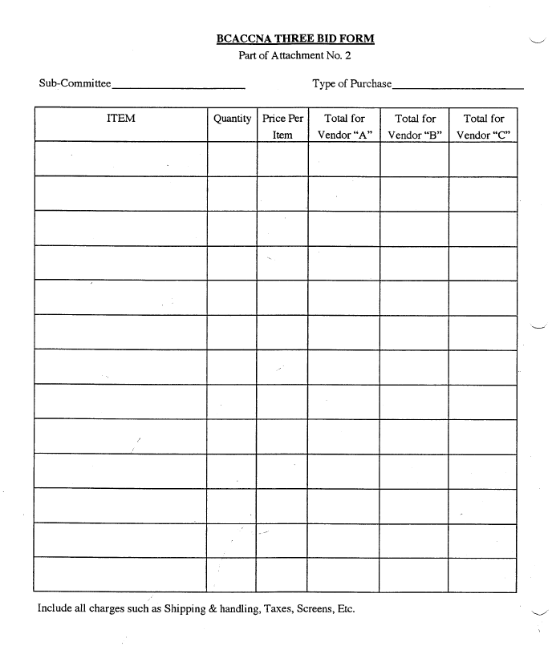

BCACCNA

Inventory Policy Attachment No.3

The guidelines for inventory control of merchandise prior to the convention are:

1. Physical inventory upon delivery of merchandise.

2. Inventory log book.

3. Receipts for money received and merchandise both in and out.

4. Spot inventory

Physical inventory must be recorded and an inventory form (form 3a) and filled out by the designated

committee member upon delivery. The invoice must then be compared to see if there are any

discrepancies. If there are any discrepancies they must be brought to the attention of the vendor.

The inventory log book will maintain merchandise being given out for sale, money received.

merchandise returned, and overall inventory.

The receipt book is to be a triplicate pre-numbered book to maintain accountability. When any

money is turned in, a receipt will be issued. When merchandise is given out or returned a

inventory control receipt will be given out and signed by both parties of the transaction. All

these receipts will be logged into the inventory control log to help maintain control of the flow of

merchandise and money.

A member of the Administrative Committee will be responsible to make a spot inventory on a

regular basis to see if all merchandise is accounted for. A spot inventory (form 3b) will be filled out at

each count.

Any person, who is selling merchandise and comes up short through actions of their own, will be responsible for the merchandise or equivalent monetary value. Persons handling merchandise should be a member of that subcommittee.
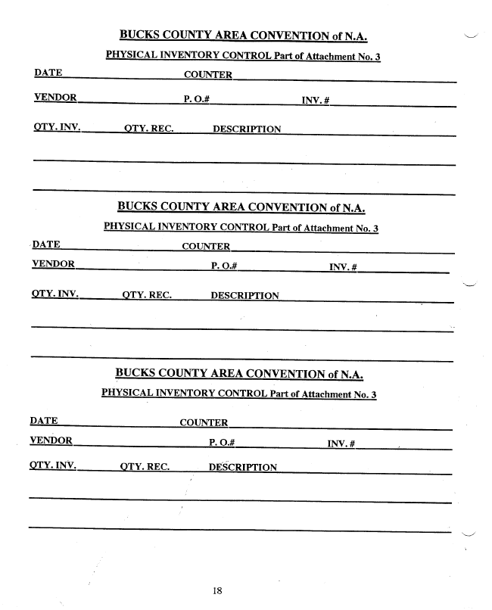

3a
3a
3a
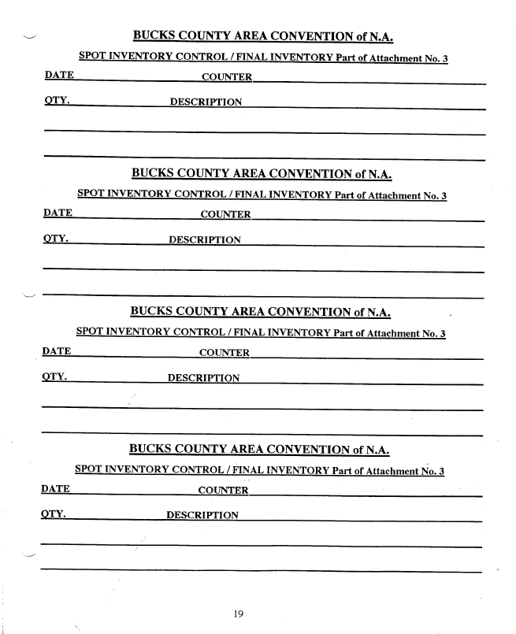

3b
3b
3b
3b

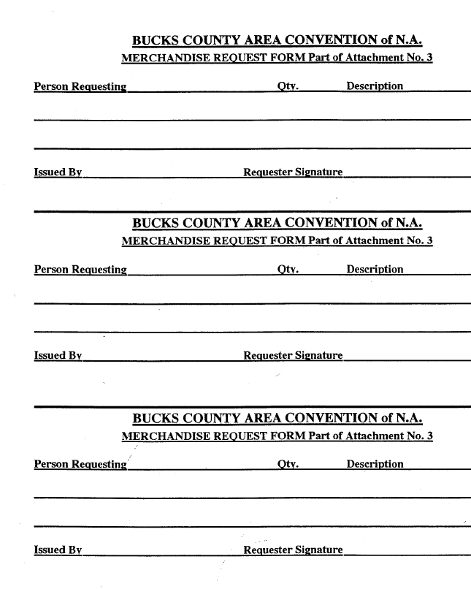
3c
3c
3c

BCACCNA

Serialized tickets Policy Attachment No.4

All Tickets sold for events shall be serialized sequentially in a professional manner. A

quantity will be printed for each event and sold in sequence. Tickets left over will be returned to

the Treasure along with sales receipts after the event. The following is an example for Sub-

Committees to follow:

Fund raising Example for projected 200 in attendance.

Tickets for event number one would be numbered 0001 through 0200, tickets for

event number two would be numbered 0201 through 0400, tickets for event number three

would be numbered 0401 through 0600 etc. Tickets for convention events will be the

responsibility of Registration.

Registration; Example for projected 300 in attendance.

Tickets for registrations would be numbered 0001 through 0300. Tickets for

banquet would be numbered 0301 through 0600. Tickets for breakfast would be

numbered 0601 through 0900. Tickets for event number one would be numbered 0901

through 1200. Tickets for event number two would be numbered 1201 through 1500, etc.

The above are examples only

